# **Enterprise Application Development**

# **Lab Test 1**

**Rules:**

1. Students can use Canvas and Internet for reference. No discussion or exchange of ideas, external support is allowed.
2. Students put all the files into a folder, zip it and submit the zipped file.
3. Sharing or disclosing lab test questions are prohibited.
4. Students make assumptions based on common sense. Please don’t ask questions that are straightforward as it can slow down your progress.

**Time: 12 hours**

**Question 1 (10 marks). HTML**

Use HTML5 drag/drop features, build a small game that helps kids learn number

<https://www.w3schools.com/html/html5_draganddrop.asp>

The game contains 10 boxes with 1 number in each box. The order of boxes is random. Kids will use drag and drop to reorder box ascending and descending.

| 6 | 3 | 2 | 4 | 19 | 5 | 1 | 24 | 14 | 23 |
| --- | --- | --- | --- | --- | --- | --- | --- | --- | --- |

**Question 2 (10 marks). CSS**

Without using any CSS framework including Bootstrap, Ant etc, design the following search pane using only pure CSS. Try to design as close to this sketch as you can.

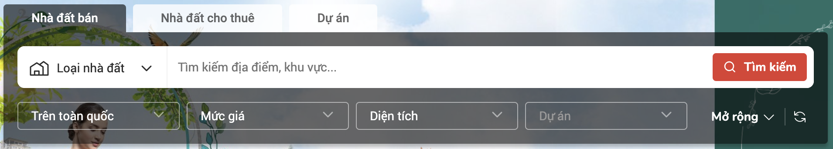

**Question 3 (10). Javascript**

Hongkong SAS Transport Service has published a public API for drivers to search for a parking place.

https://api.data.gov.hk/v1/carpark-info-vacancy?data=<param>&vehicleTypes=<param>&carparkIds=<param>&extent=<param>&lang=<param>

The detailed explanation for API can be found in here.

<https://data.gov.hk/en-data/dataset/hk-ogcio-st_div_04-carpark-info-vacancy/resource/81c45810-cd90-4812-a5bd-923744df3aba>

* Build a simple web page to show all the parking locations with as detailed information as possible. You may need to use the show/hide button or Read more… to display more information about parking.
* Have pagination to show list page by page.
* Add filters (select box) by vehicle types and 2 other values that you find necessary.
* Add search by address and name of parking